I’ve installed mantis

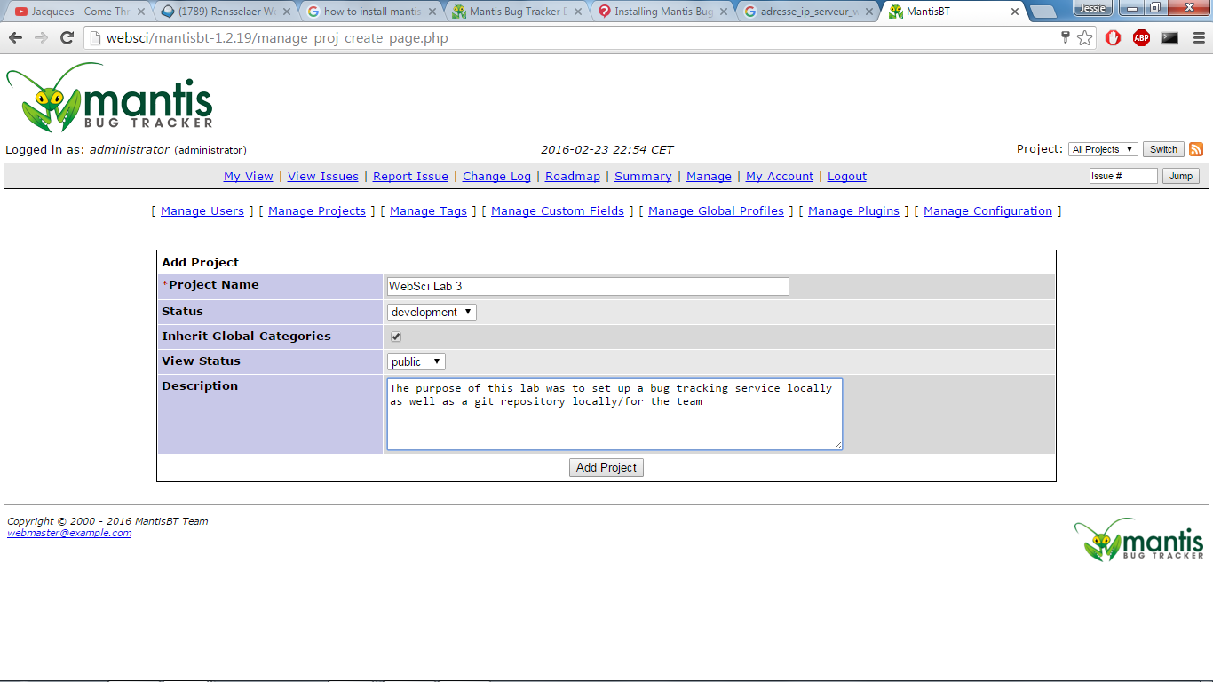

Group Server: Heroku, Plotka is added the link is provided

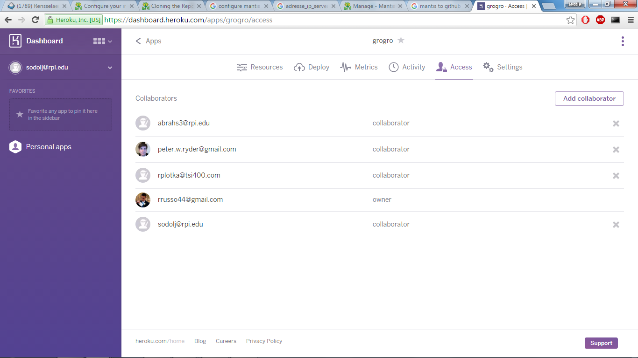

https://dashboard.heroku.com/apps/grogro/deploy/github